Case Report

Agranulocytosis due to Piperacillin-Tazobactam Manifested by an Atypical Symptom: A Case Report

Royce Johnson¹, Kevin Chen⁴, Carlos D’Assumpcao¹, William Stull³, Rasha Kuran¹, Michelle Fang¹, Stanley Kim^{2*}

¹Division of Infectious Disease, Department of Medicine, Kern Medical, Bakersfield, CA, USA
²Division of Hematology-Medical Oncology, Department of Medicine, Kern Medical, Bakersfield, CA, USA
³Department of Pathology, Kern Medical, Bakersfield, CA, USA
⁴Western University of Health Sciences - College of Osteopathic Medicine of the Pacific, Pomona, CA, USA

*Corresponding Author: Stanley Kim, Division of Hematology-Medical Oncology, Department of Medicine, Kern Medical, Bakersfield, CA, USA. Mail Id: example@gamil.com

Abstract
Agranulocytosis induced by antibiotics is a life-threatening, indiosyncratic drug reaction. It may be asymptomatic, but is often accompanied by fever, chill, sore throat and mouth ulcers. We present a patient with invasive otitis externa and skull base osteomyelitis who was receiving long-term piperacillin-tazobactam at home and developed agranulocytosis 22 days after the initiation. The only symptom was severe body aches, which prompted her to visit the hospital emergency room where a complete blood count (CBC) revealed agranulocytosis. Although home-based outpatient parenteral antibiotic therapy (OPAT) is increasingly utilized, close monitoring akin to hospital care is logistically unfeasible in the outpatient setting, which makes early identification of serious adverse complications such as agranulocytosis difficult.

Keywords: Agranulocytosis; Piperacillin-Tazobactam; Outpatient Parental Antibiotic Therapy; Atypical Symptom of Agranulocytosis.

Introduction

Agranulocytosis is a life-threatening condition characterized by an absolute neutrophil count (ANC) of less than 0.5 × 109 cells/L [1]. Most agranulocytosis cases are acquired, predominately due to medication use, but also may be due to chemicals, autoimmune conditions, and infectious etiologies [1,2]. Medication-induced agranulocytosis results from cytotoxic effects or idiosyncratic reactions. Cytotoxic effects involve direct damage to myeloid precursors through metabolites and chemically reactive intermediates such as those observed with bioactivated cytotoxic metabolites of clozapine [4]. Idiosyncratic drug-induced agranulocytosis occurs unpredictably, is not dose dependent, and is probably immune-mediated [1,4]. A recent study showed that antibiotic-induced neutropenia is not rare and that beta-lactam antibiotics are often implicated [6]. The typical symptom triad is fever, sore throat, and mouth ulcers [1,3]. Early clinical detection of agranulocytosis may be difficult as patients may be asymptomatic or have minimal symptoms. Piperacillin-tazobactam is a beta-lactam and beta-lactamase inhibitor with broad spectrum antibacterial activity that is commonly used in the setting of gram-positive and gram-negative aerobic and anaerobic bacterial infections and is generally safe with good tolerability [7,8]. In this case report, we present a unique case of agranulocytosis attributed to piperacillin tazobactam in which the patient presented with the atypical single symptom of severe body aches.

Case Presentation

A 35-year-old woman initially developed pain and swelling of the right ear 2 months prior to admission. She had been treated with topical eardrops containing ciprofloxacin and clotrimazole as well as oral antibiotics including cephalexin, clindamycin and amoxicillin, but without significant improvement. Past medical history includes obesity and Roux-en-Y gastric bypass surgery 5 years prior to admission. She had been taking bariatric vitamin supplementation until 1 month ago. Worsening pain prompted the patient to present to the emergency room (ER). CT scan showed complete opacification of the right external auditory canal, middle ear cavity and mastoid air cells with osseous destruction consistent with invasive otitis externa and skull base osteomyelitis. She was admitted and received intravenous (IV) vancomycin and piperacillin- tazobactam for 8 days during hospitalization. Several cultures of the ear discharge fluid were negative, presumably due to previous antibiotic therapy. The complete blood count (CBC) with differential counts were normal throughout the hospitalization. Her symptoms improved and an infectious disease consultant recommended 6 more weeks of IV piperacillin-tazobactam without vancomycin. After hospital discharge, she continued IV piperacillin-tazobactam, 3.375 g every 6 hours at home through a peripherally inserted central (PICC) line. She was monitored with weekly CBC with differential and comprehensive metabolic panel (CMP) under the Outpatient Parenteral Antibiotic Therapy (OPAT) program of our institution. Fourteen days after the start of home IV antibiotic therapy (total 22 days including in-hospital therapy), she developed severe body aches, which occurred after injecting the antibiotic into her PICC line. Therefore, she presented to the ER. She described it as ‘excruciating pain all over the body’ but denied associated fever, sore throat, mouth ulcer, skin rash, or itching. The patient has no known drug allergies, including penicillin. In the ER, CBC revealed white blood cell (WBC) count of 3.0 x 109/L and ANC 0.1 x 109/L (Table 1). The manual differential counts demonstrated: 3% segmented neutrophils, 1% band neutrophils, 65% lymphocytes, 13% monocytes, 14% eosinophils, and 2% basophils. She was admitted to the hospital. The peripheral blood smear showed no granulocytes (Figure 1). The outpatient CBC done a day before this 2nd admission showed WBC 3.2 x 109/L with ANC 0.1 x 109/L but had not yet come to the attention of the OPAT team. The CBC of 1 week prior was normal with ANC 5.0 x 109/L. The complete metabolic panel results including renal and liver function tests were within normal limits. HIV 1,2 Combo serology was negative. The immunoglobulin (Ig) levels of IgE, IgA, IgM, and IgG were normal. She had cold symptoms with chest congestion, production of clear phlegm and occasional chilly sensation without fever since the previous hospitalization, which was 2 weeks prior to admission. Her 2 children had cold-like symptoms of rhinorrhea and cough. The multiplex viral molecular testing from the throat swab showed positive human rhinovirus/enterovirus. However, the chest X-ray was unremarkable without acute cardiopulmonary disease.

On the day (Day 1) of hospitalization, she received one dose of IV piperacillin-tazobactam, but she developed the same severe body pain. Immediately it was discontinued and switched to IV cefepime. Daily filgrastim 480 mcg (weight > 60 kg) was started subcutaneously. Morphine Sulfate 2 mg IV relieved the severe pain. On Day 2, ANC was still low at 0.2 x109/L, but she no longer required the morphine as the body ache subsided. On Day 3, ANC increased to 10.9 x109/L. The peripheral blood smear showed markedly increased granulocytes (Figure 2). The filgrastim was discontinued. On Day 4, WBC was 11.0 x 109/L and the manual differential count demonstrated: 64% segmented neutrophils, 1% bands, 27% lymphocytes, 4% monocytes, 4% eosinophils and 0% basophils. The ANC was measured 7.2 x109/L. The patient did not develop any side effects with the cefepime and was subsequently discharged.

Day | WBC  (cell x 10⁹/L) | ANC  (cell x 10⁹/L) | Hemoglobin  (g/dL) | Platelet  (cell x 10⁹/L)
1 | 3 | 0.1 | 13.1 | 312
2 | 3.7 | 0.2 | 12.2 | 309
3 | 16.4 | 10.9 | 13.2 | 324
4 | 11 | 7.2

Table 1: Complete Blood Count.

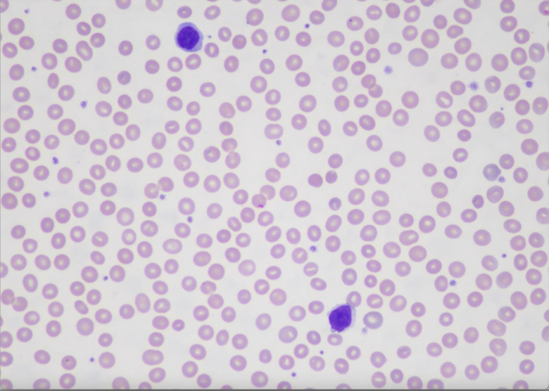
Figure 1: Peripheral blood smear on Day 1 shows no granulocytes.

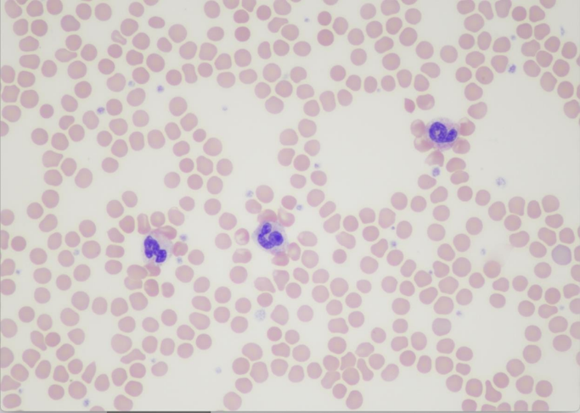
Figure 2: Peripheral blood smear on Day 3 shows increased circulating granulocytes.

Discussion

The incidence of agranulocytosis induced by non-chemotherapy drugs was reported very rare occurring 7.2 cases per million per year [9]. However, a recent study [6] showed that antibiotic- induced neutropenia and agranulocytosis are not so rare. Out of 2513 treatments courses, 55 cases of neutropenia (defined as ANC <1.5 x109/L) and 16 cases of agranulocytosis (ANC <0.5 x109/L) were identified. In particular, neutropenia due to piperacillin-tazobactam occurred in 6 cases out of 446 treatments courses with the incidence of 1.35%. Idiosyncratic drug-induced agranulocytosis occurs unpredictably, is not dose dependent, and is probably immune-mediated [1,4]. The evidence of its immune mechanism includes a delayed onset of the reaction after initiation of the therapy, the rapid reappearance of the reaction after resumption of the medicine, appearance of eosinophilia, formation of drug-dependent neutrophil antibodies, and the association of idiosyncratic reactions with specific HLA gene variants in some cases [1]. Our patient developed agranulocytosis while receiving antibiotics at home. The home-based OPAT is increasingly utilized because patients with complicated infections can safely complete the prolonged courses of therapy in a familiar environment, while minimizing the exposure to the hospital-acquired infections and decreasing costs [10,11]. However, it lacks the close monitoring offered in the hospital setting, which makes early identification of adverse complications such as agranulocytosis difficult, especially when patients have no classic symptoms. Our patient was monitored with weekly CBC according to the OPAT program of our institution. The day before she was readmitted, the CBC done by our OPAT protocol showed agranulocytosis (WBC 3.2 x 109/L with ANC 0.1 x 109/L) which coincided with the onset of the body aches. The CBC done a week prior was normal. Therefore, because of the one-week gap, we cannot be sure how many days she had agranulocytosis before she developed the body aches. It is noticeable that our patient developed severe body aches right after infusion of the antibiotic of which reason is not clear. Nevertheless, without the body aches, she could have continued the antibiotic, which might have resulted in a dreadful consequence in this patient with serious infection. As severe body pain is not a typical symptom of agranulocytosis, clinicians should be aware that agranulocytosis may be manifested by atypical symptoms such as severe body aches as seen in our patient.

Our patient reported ‘cold’ symptoms with chest congestion and occasional chilly sensation without fever for 2 weeks before the 2nd admission. The viral molecular test came back positive for rhinovirus/enterovirus. One may think that the common cold viral infection could have caused agranulocytosis in this case. Transient mild to moderate neutropenia may be caused by various common viral infections during childhood. In most cases, neutropenia occurs during the first few days of the viral illness and persists for 3-8 days [12]. But our patient developed agranulocytosis more than 2 weeks after her first cold symptoms. Although any viral infection can cause transient mild neutropenia, more profound neutropenia may occur in certain viral infections (HIV, Epstein-Barr virus, cytomegalovirus, influenza, and parvovirus B19) [2]. There are limited data describing the frequency or natural history of neutropenia associated with upper respiratory viral infection in adults. A retrospective study showed that among 436 adult patients hospitalized with severe influenza infection during the influenza season, about 15% developed neutropenia. Majority of cases were mild with the ANC over 1.0 x 109/L [13]. We found no report of agranulocytosis (ANC <0.5× 109 cells/L) induced by rhinovirus or other common cold viruses occurred in adults in the PubMed database. It is highly unlikely that agranulocytosis was caused by common cold virus infection. The mortality of drug-induced agranulocytosis is as high as 5% [2,14]. However, there are no specific recommendations for patients on OPAT in detecting agranulocytosis early. The Infectious Disease Society of America recommends laboratory test monitoring but has no specifics about the type of laboratory tests and frequency of monitoring for individual antimicrobials [15]. UK good practice recommendations for OPAT suggest weekly laboratory monitoring for all patients without specific guidelines [16]. The onset and incidence of agranulocytosis are different among various antimicrobials. For example, the median duration of beta-lactam antibiotics exposure before onset of agranulocytosis is in a range of 19-25 days [14]. In the case of vancomycin, the agranulocytosis occurs after a minimum of 7 days of treatment, with the majority occurring at least 20 days after initiation of treatment [17]. In our patient, agranulocytosis was found 22 days after the initiation of piperacillin-tazobactam treatment. Having no clear and specific guidelines, health care facilities monitor their patients on OPAT differently. The OPAT protocol of our institution requires weekly monitoring with CBC with differentials and CMP. A Canadian hospital starts monitoring at week 3 of antibiotic therapy while those on vancomycin at week one [6]. Others have suggested that patients on a short duration of OPAT and using lower risk antibiotics could be followed with less frequent laboratory tests [18]. As more patients are using OPAT for complicated infections, it may well be time to develop specific guidelines.

Conclusion

We report a case of agranulocytosis induced by piperacillin-tazobactam which is one of the most commonly used antibiotics. Agranulocytosis may be asymptomatic, but is often accompanied by fever, sore throat and mouth ulcers. Our patient developed extreme body aches about 3 weeks after initiation of home piperacillin/tazobactam given for severe invasive ear infection, which lead her to go to the ER where agranulocytosis was discovered. As severe body pain is not a usual symptom of agranulocytosis, clinicians should be aware that agranulocytosis may be manifested by atypical symptoms. Our patient received the antibiotic via home-based OPAT, which is more frequently utilized, but lacks close monitoring of patients for early detection of complications. Currently there are no detailed guidelines for OPAT specifying the type, frequency and duration of the laboratory tests for individual antimicrobials. It may be reasonable to develop more specific guidelines for antimicrobials known to cause agranulocytosis or other morbid complications.

Declarations

Contributors: All authors contributed to planning, literature review and conduct of the review article. All authors have reviewed and agreed on the final manuscript.

Competing interests: None

Patient consent for publication: Informed consent was obtained from the patient, consent form available upon request / Not applicable

Ethics approval and consent to participate: Ethical approval for this publication by IRB at Kern Medical / Not applicable

Availability of data and materials: Not applicable

Funding: Received From…/ None from any funding agency in the public, commercial or not-for-profit sectors. / Not applicable/No Funding

References

- Rattay B, Benndorf RA. (2021) Drug-Induced Idiosyncratic Agranulocytosis - Infrequent but Dangerous. Front Pharmacol. 12:727717.
- Newburger PE. (2016) Autoimmune and other acquired neutropenias. Hematology Am Soc Hematol Educ Program. 1: 38-42.
- Stamer U. M, Gundert-Remy U, Biermann E, Erlenwein J, Meiβner W, et al. (2017). Dipyrone (Metamizole) : Considerations on Monitoring for Early Detection of Agranulocytosis. Schmerz. 31:5–13.
- Johnston A, Uetrecht J. (2015) Current understanding of the mechanisms of idiosyncratic drug- induced agranulocytosis. Expert Opin Drug Metab Toxicol. 11:243-57.
- Mijovic A, MacCabe J (2020) Clozapine-induced agranulocytosis. Ann Hematol. 99:2477-2482.
- Lam PW, Leis JA, Daneman N. (2023) Antibiotic-Induced Neutropenia in Patients Receiving Outpatient Antibiotic Therapy: a Retrospective Cohort Study. Antimicrob Agents Chemother. 67: e01596-22.
- Perry CM, Markham A. (1999) Piperacillin/tazobactam: an updated review of its use in the treatment of bacterial infections. Drugs. 57:805-43.
- Qian ET, Casey JD, Wright A, Wang L, Shotwell MS, et al (2023) Vanderbilt Center for Learning Healthcare and the Pragmatic Critical Care Research Group. Cefepime vs Piperacillin-Tazobactam in Adults Hospitalized with Acute Infection: The ACORN Randomized Clinical Trial. JAMA. 330:1557-1567.
- Strom BL, Carson JL, Schinnar R, Snyder ES, and Shaw M. (1992). Descriptive Epidemiology of Agranulocytosis. Arch. Intern. Med. 152: 1475–1480.
- Staples JA, Ho M, Ferris D, Hayek J, Liu G, Tran KC, et al (2022) Outpatient Versus Inpatient Intravenous Antimicrobial Therapy: A Population-Based Observational Cohort Study of Adverse Events and Costs. Clin Infect Dis. 75:1921-1929.
- Wolter JM, Cagney RA, McCormack JG. (2004) A randomized trial of home vs hospital intravenous antibiotic therapy in adults with infectious diseases. J Infect. 48:263-8.
- Segel GB, Halterman JS. (2008) Neutropenia in pediatric practice. Pediatr Rev. 29: 12-23.
- Higgins P, Runnegar N, Bird RJ, Markey KA. (2016) Rates of neutropenia in adults with influenza A or B: a retrospective analysis of hospialised patients in Southern East Queensland during 2015. Internal Med. J. 46:1328-1332.
- Andersohn F, Konzen C, Garbe E. (2007) Systematic review: agranulocytosis induced by nonchemotherapy drugs. Ann Intern Med. 146:657-65.
- Norris A, Shrestha N, Allison G, Keller S, Bhavan K, et al. (2019) 2018 Infectious Diseases Society of America Clinical Practice Guideline for the Management of Outpatient Parenteral Antimicrobial Therapy. Clin. Infect. Dis. 68:e1–e35.
- Chapman ALN, Patel S, Horner C, Green H, Guleri A, et al (2019) Updated good practice recommendations for outpatient patenteral antimicrobial therapy (OPAT) in adults and children in the UK. JAC Antimicrob Resist 1:dlz026.
- Blake E, Lau TT, Ensom MH. (2011) Vancomycin-induced neutropenia: is it dose-or duration- related? Ann Pharmacother. 45:629.
- Frisby J, Ali N, Niemotka S, Abate G. (2023) Usefulness of Routine Laboratory Tests for Follow up of Patients Receiving Outpatient Parenteral Antimicrobial Therapy Run by Infectious Diseases Fellows. Antibiotics (Basel). 12:330.

